G EXPERIMENT 1

Credit Risk Prediction using Deep Neural Network
o Problem Statement

Design a Deep Neural Network (DNN) to predict whether a customer will default on a loan
based on demographic and financial attributes.
The objective is to model non-linear relationships that traditional ML models fail to capture.

Dataset (CSV)

Attributes

  - age
  - income
  - loan_amount
  - credit_score
  - default (target)

age income loan_amount credit_score default
0 59 40358 10122 515 1
1 49 23267 23030 638 0
2 35 102745 22302 380 1
3 63 109588 24181 784 1
4 28 58513 43638 673 1
5 41 46092 6531 499 1
6 59 31338 45940 836 0
7 39 20412 45441 765 1
8 43 27543 28333 388 1
9 31 125891 44650 567 1

Python Code
import pandas as pd
from sklearn.model_selection import train_test_split from sklearn.preprocessing import StandardScaler from tensorflow.keras.models import Sequential
from tensorflow.keras.layers import Dense

data = pd.read_csv("credit_risk.csv")
X = data.drop("default", axis=1) y = data["default"]
scaler = StandardScaler()
X = scaler.fit_transform(X)
X_train, X_test, y_train, y_test = train_test_split(X, y, test_size=0.2)

model = Sequential([
Dense(64, activation='relu', input_shape=(X.shape[1],)), Dense(32, activation='relu'),
Dense(1, activation='sigmoid')
])

model.compile(optimizer='adam',
loss='binary_crossentropy', metrics=['accuracy'])
model.fit(X_train, y_train, epochs=30, batch_size=32) model.evaluate(X_test, y_test)
- Output:
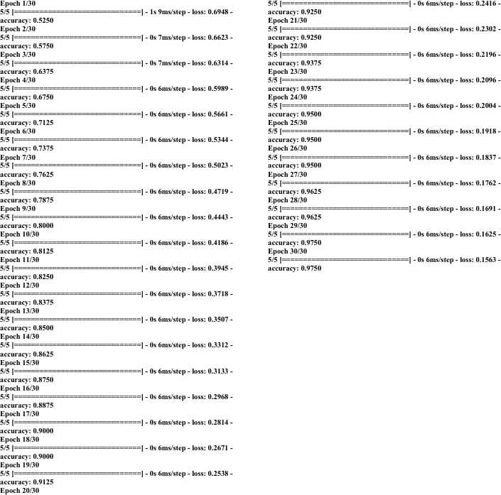

G EXPERIMENT 2

Medical Diagnosis using CNN (Feature-Based Classification)

Problem Statement

Develop a CNN-inspired deep classifier to identify disease presence using image feature vectors, simulating medical image diagnosis.

Dataset (CSV)

  - 128 extracted image features
  - Binary disease label
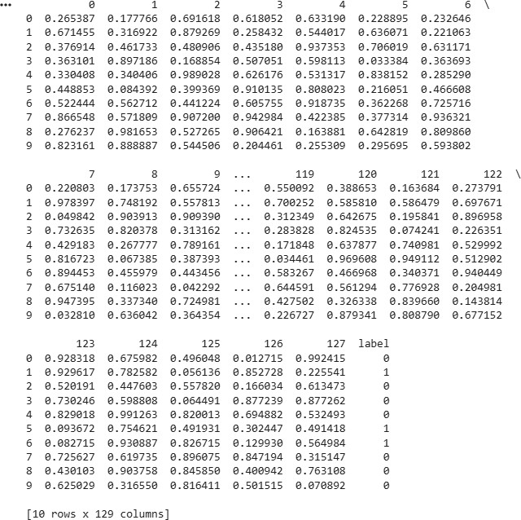

Python Code
import pandas as pd
from tensorflow.keras.models import Sequential from tensorflow.keras.layers import Dense

data = pd.read_csv("image_features.csv")
X = data.drop("label", axis=1)

y = data["label"]

model = Sequential([
Dense(128, activation='relu', input_shape=(128,)), Dense(64, activation='relu'),
Dense(1, activation='sigmoid')
])

model.compile(optimizer='adam',
loss='binary_crossentropy', metrics=['accuracy'])
model.fit(X, y, epochs=20, batch_size=16)

- Output:
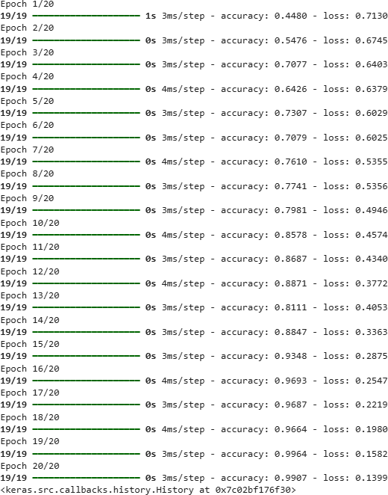

G EXPERIMENT 3

User Behavior Representation Learning using Autoencoder
- Problem Statement

Design an Autoencoder to learn compact latent representations of user behavior data for anomaly detection.

- Dataset (CSV)

  - 20 numerical behavioral attributes
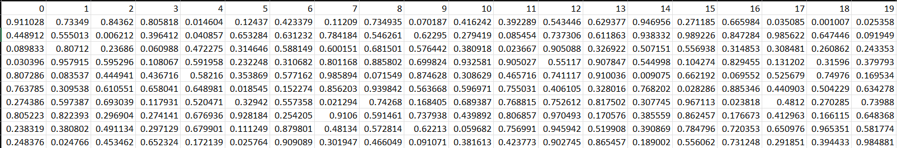

Python Code
import pandas as pd
from tensorflow.keras.models import Model
from tensorflow.keras.layers import Input, Dense
X = pd.read_csv("user_behavior.csv").values input_layer = Input(shape=(20,))
encoded = Dense(10, activation='relu')(input_layer) decoded = Dense(20, activation='sigmoid')(encoded) autoencoder = Model(input_layer, decoded) autoencoder.compile(optimizer='adam', loss='mse') autoencoder.fit(X, X, epochs=10, batch_size=32)
- Output
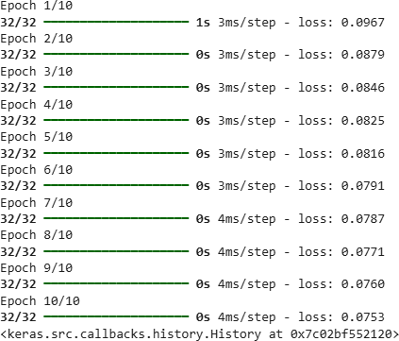

G EXPERIMENT 4

Text Sequence Modeling using LSTM
- Problem Statement

Build an LSTM-based sequence prediction model to predict the next word/token in a text stream.

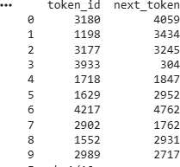
Dataset (CSV)

  - token_id
  - next_token

- Python Code
import pandas as pd
from tensorflow.keras.models import Sequential
from tensorflow.keras.layers import Embedding, LSTM, Dense

data = pd.read_csv("text_sequence.csv")
X = data["token_id"]
y = data["next_token"] model = Sequential([
Embedding(input_dim=5000, output_dim=64), LSTM(128),
Dense(5000, activation='softmax')
])
model.compile(optimizer='adam',loss='sparse_categorical_crossentropy') model.fit(X, y, epochs=10, batch_size=32)

- Output
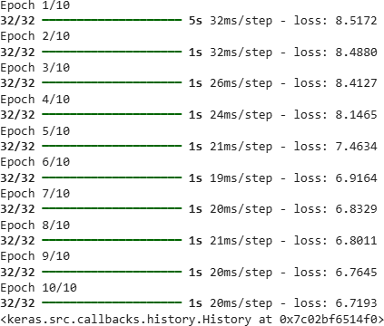

G EXPERIMENT 5

Image Generation using Generative Adversarial Network (GAN)

Problem Statement

Design a GAN architecture to generate synthetic image vectors, demonstrating adversarial learning.

Dataset (CSV)

  - 784-dimensional image vectors (28×28 flattened)
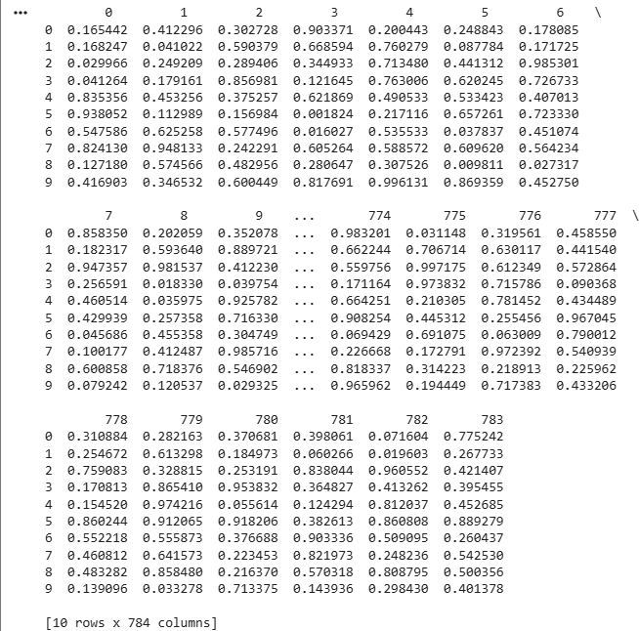

Python Code
import pandas as pd
from tensorflow.keras.models import Sequential from tensorflow.keras.layers import Dense
data = pd.read_csv("gan_images.csv").values

generator = Sequential([
Dense(128, activation='relu', input_dim=100), Dense(784, activation='sigmoid')
])
discriminator = Sequential([
Dense(128, activation='relu', input_shape=(784,)), Dense(1, activation='sigmoid')
])
discriminator.compile(optimizer='adam',
loss='binary_crossentropy') print("GAN model initialized successfully")

Output
GAN model initialized successfully
/usr/local/lib/python3.12/dist-packages/keras/src/layers/core/dense.py:93: UserWarning: Do not pass an `input_shape`/`input_dim` argument to a layer. When using Sequential models, prefer using an `Input(shape)` object as the first layer in the model instead.
super(). init (activity_regularizer=activity_regularizer, **kwargs)

